**AWS Task-4**

**Task Description:**

Launch an EC2 instance (Linux and Windows) along with a web server. Then, create an EBS volume of 5 GB, attach it to an EC2 machine (Linux and Windows), and take a snapshot. Finally, create an EBS volume using the taken snapshot.

**Techstacks needs to be used :**

* AWS EBS
* AWS EC2

**How do I submit my work?**

* Push all your work files to GitHub (O/P screenshot images must).
* Submit your URLs in the portal.

**Terms and Conditions?**

* You agree to not share this confidential document with anyone.
* You agree to open-source your code (it may even look good on your profile!). Do not mention our company’s name anywhere in the code.
* We will never use your source code under any circumstances for any commercial purposes; this is just a basic assessment task.

**NOTE:** Any violation of Terms and conditions is strictly prohibited. You are bound to adhere to it.

**54.90.249.87**

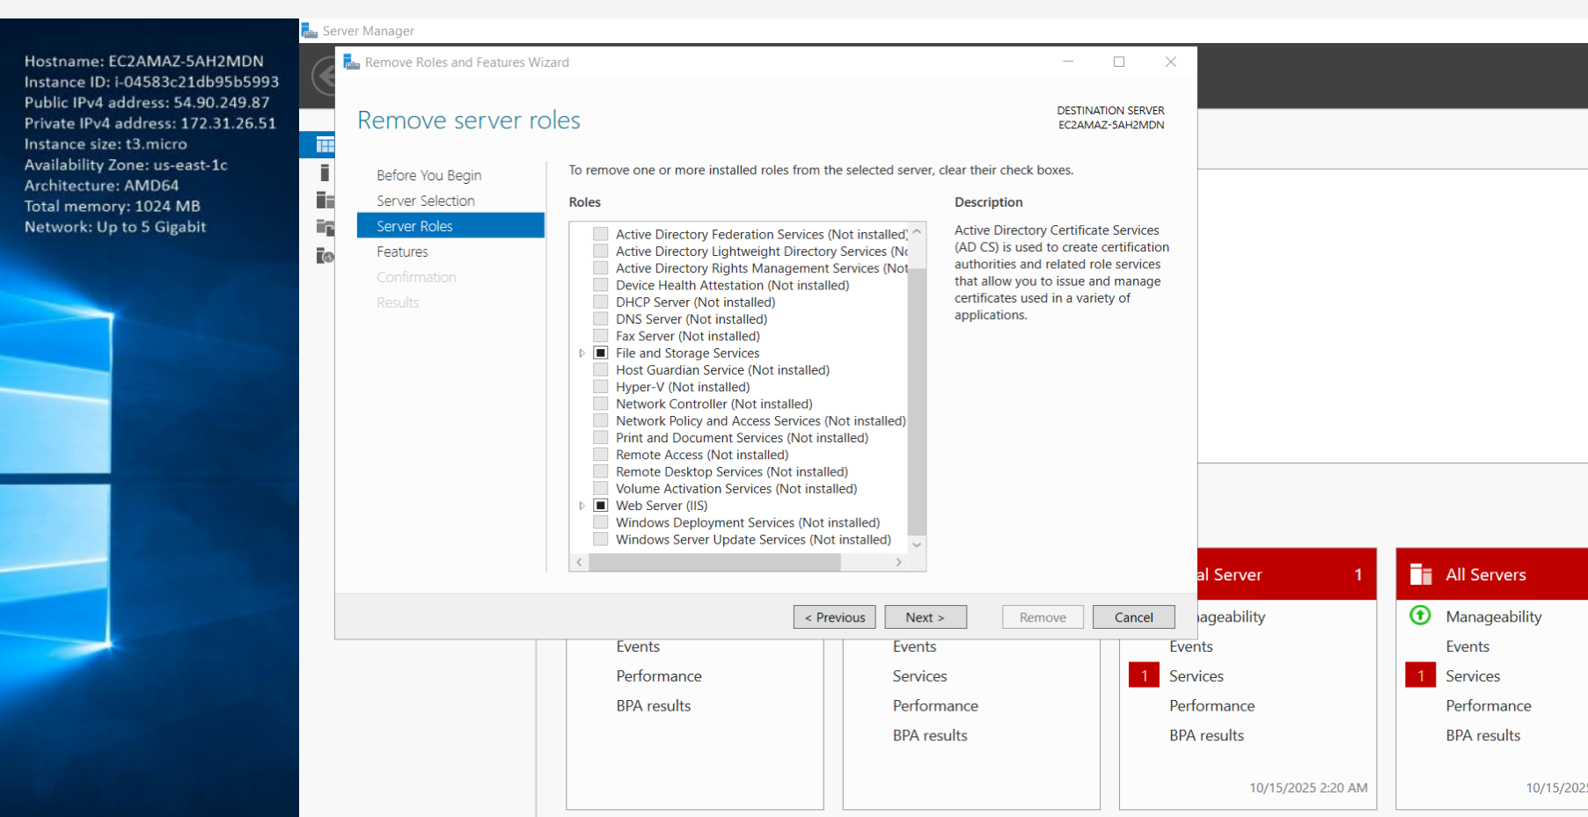

website

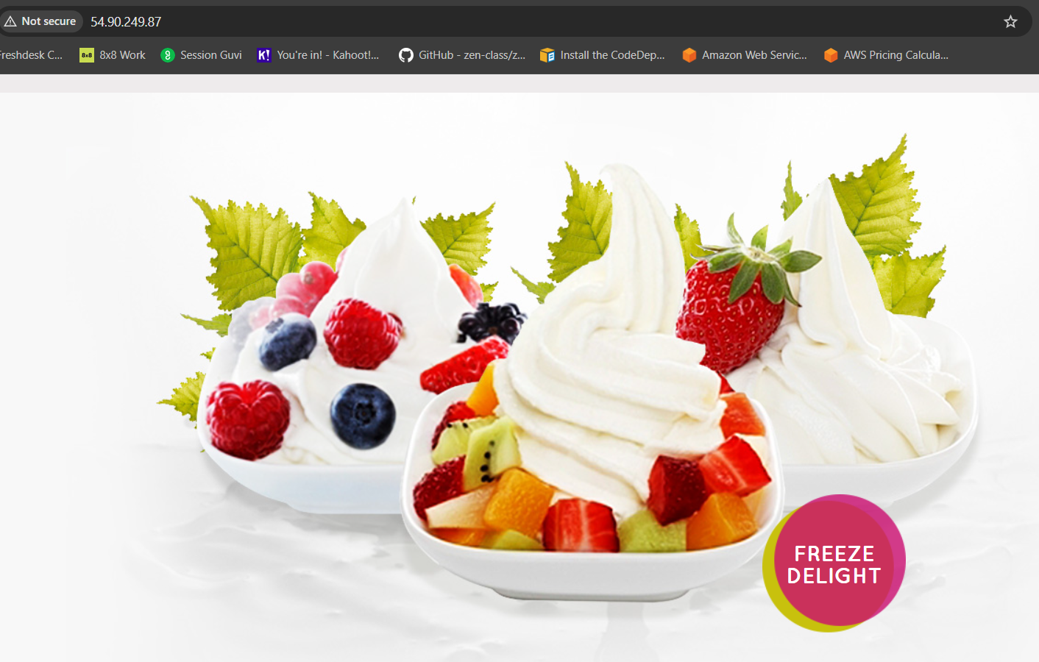

Attach new volume 6GB in windows instance

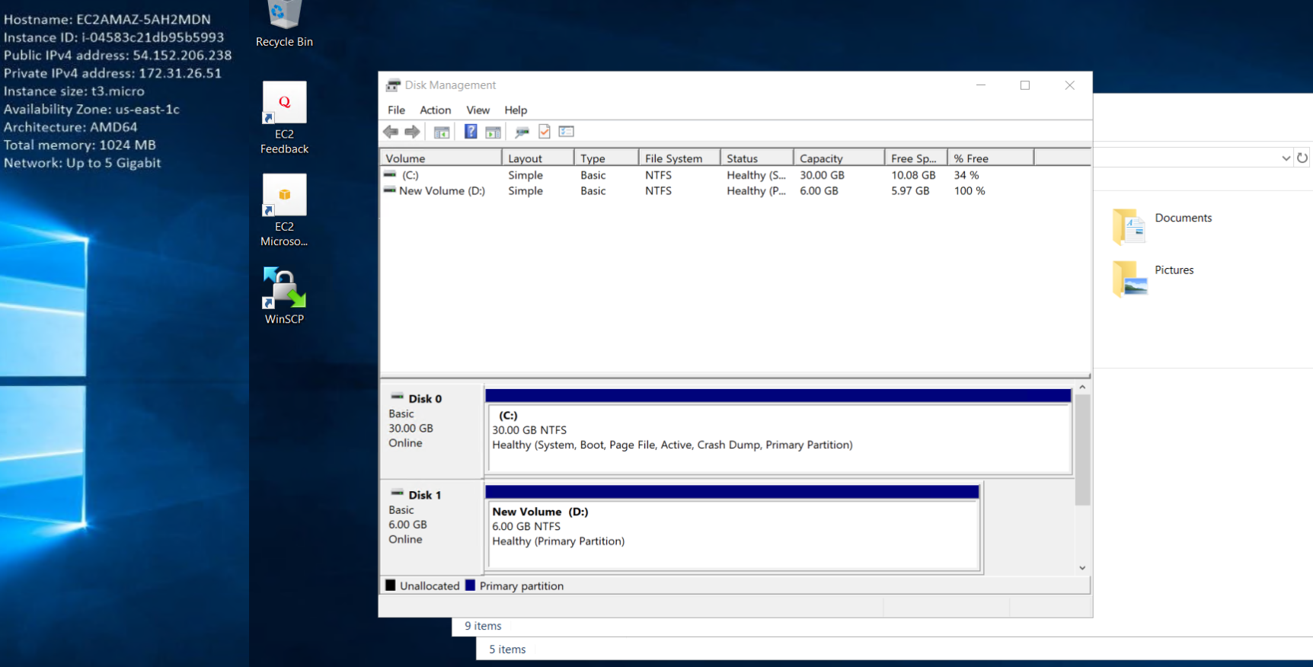

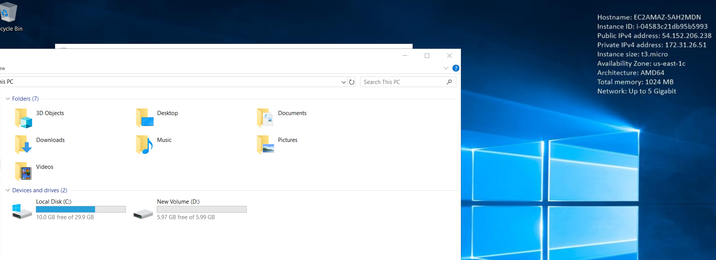

Snapshot created

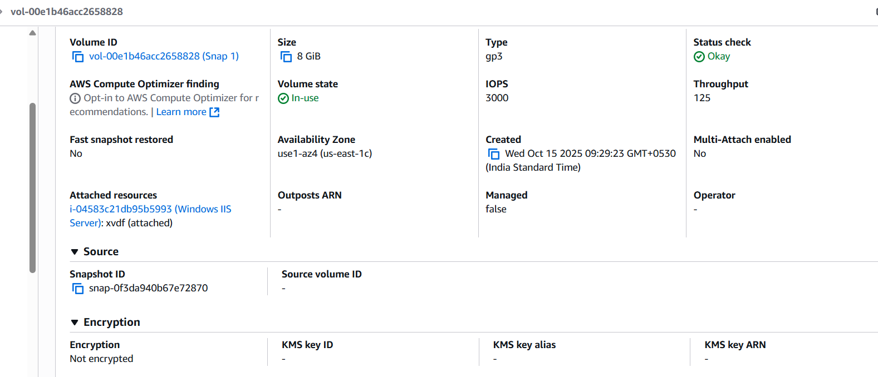

Attach the snapshot volume

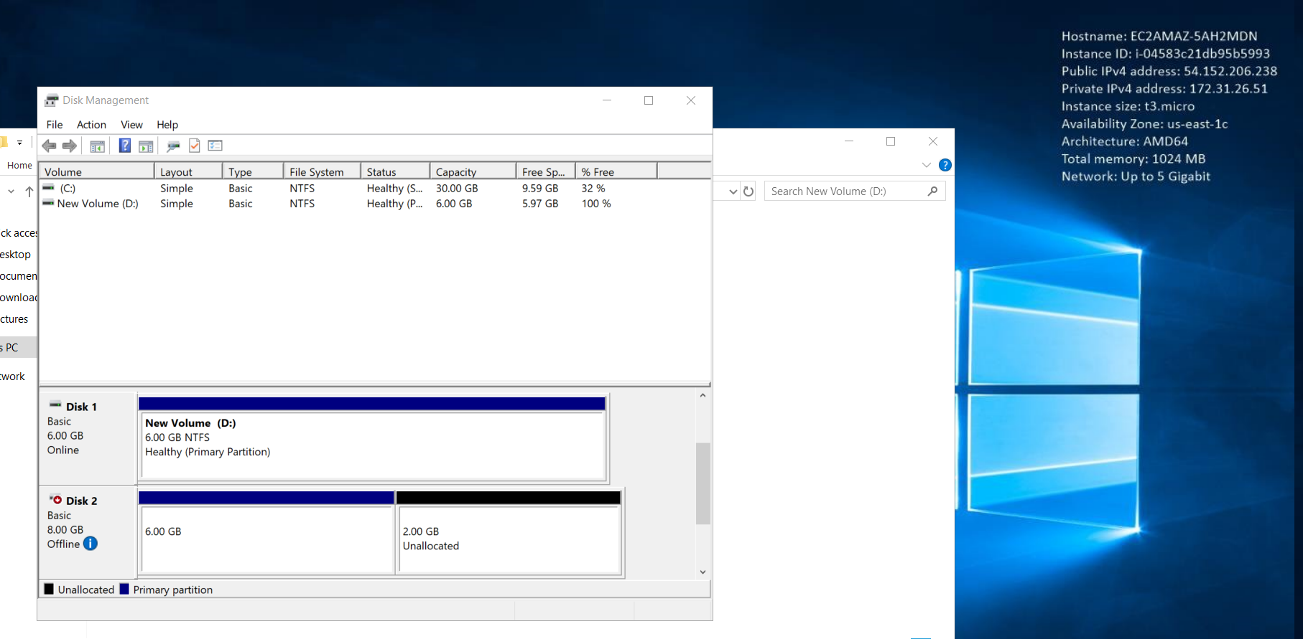

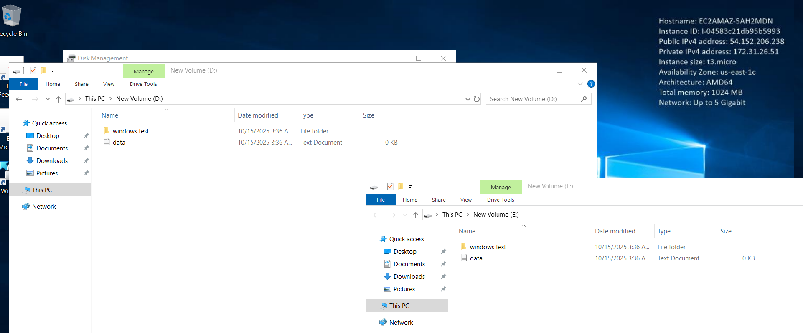

**54.221.79.201**

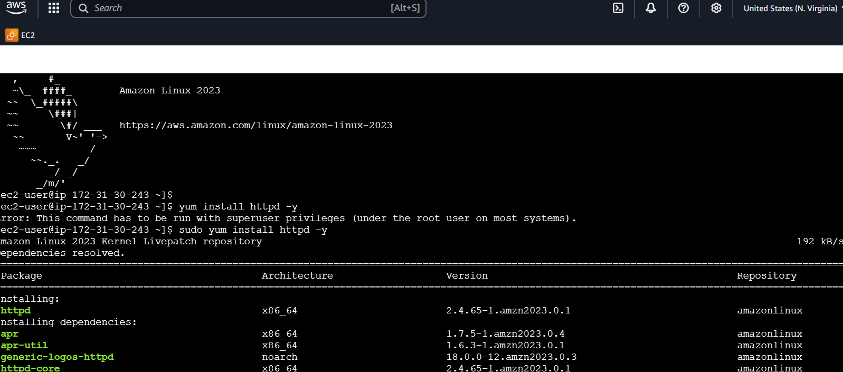

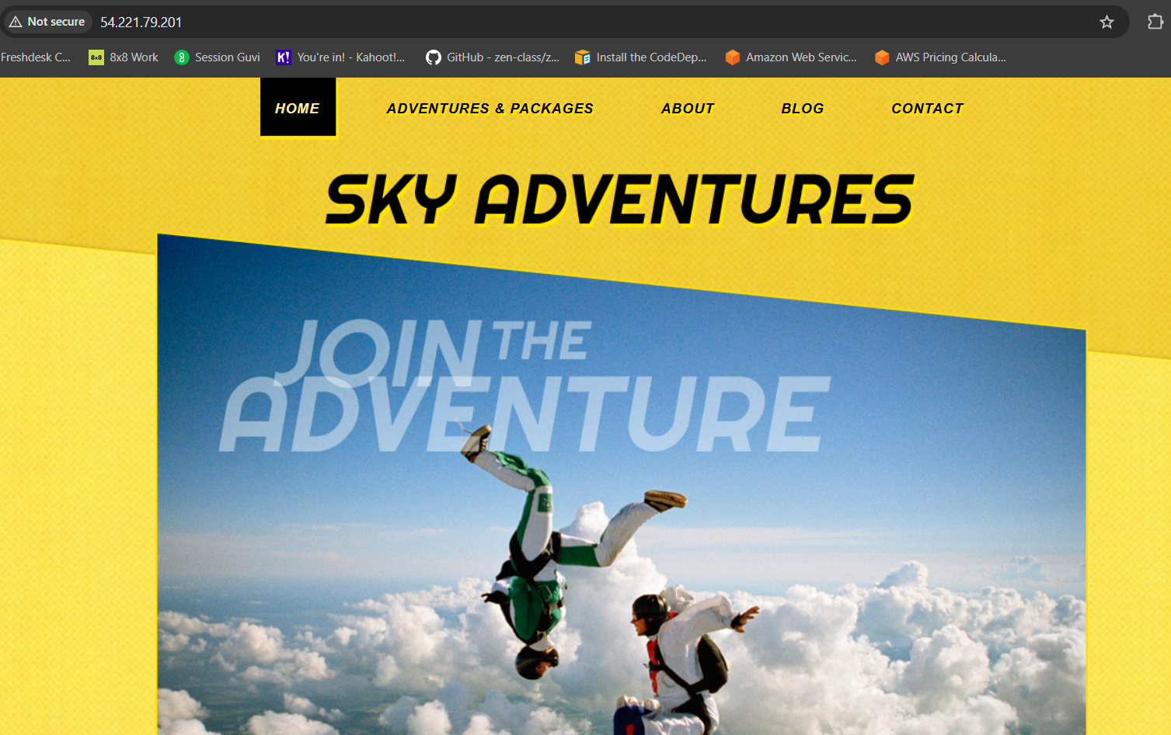

Mount new drive in linux

